Become a Brainrot — Why We're Bleeding, and the Fixes
Universe 9963622286 · 2026-08-07 · LiveOps Analytics · We find & report — we don't ship.
PUBLISH NOW
The decline starts 30 July (deploy v535–v546), not the 20–22 July dip (which recovered). Jul 29 → Aug 5: DAU −57%, revenue −58%, paying users −69%.
Collision + rebirth: fixed in dev → publish. Data-loss (wiping inventories): NOT fixed anywhere — patch it before/with the publish, or accounts keep getting wiped.

The bleed
The sustained drop starts 30 July 2026 (a 12-version deploy). It is a different event from the 20–22 July dip, which recovered.
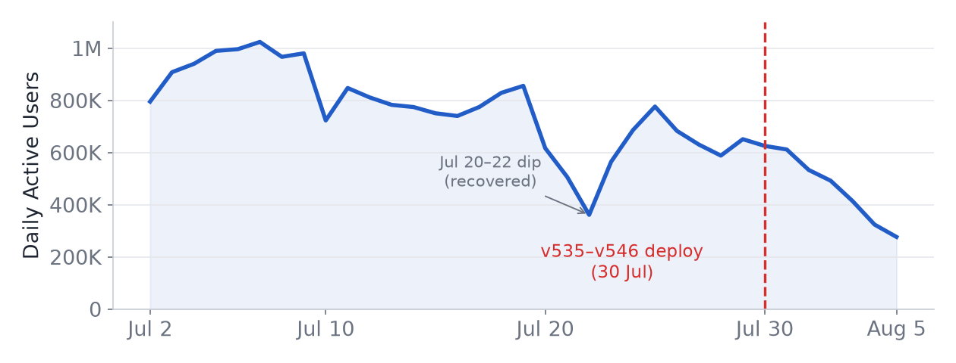
Daily Active Users. Red line = the 30 Jul deploy. The Jul 20–22 dip recovered by Jul 25; the 30 Jul decline does not.
It's a quality problem, not a traffic one. Rate metrics (independent of audience size) all break on the same day, on both platforms:
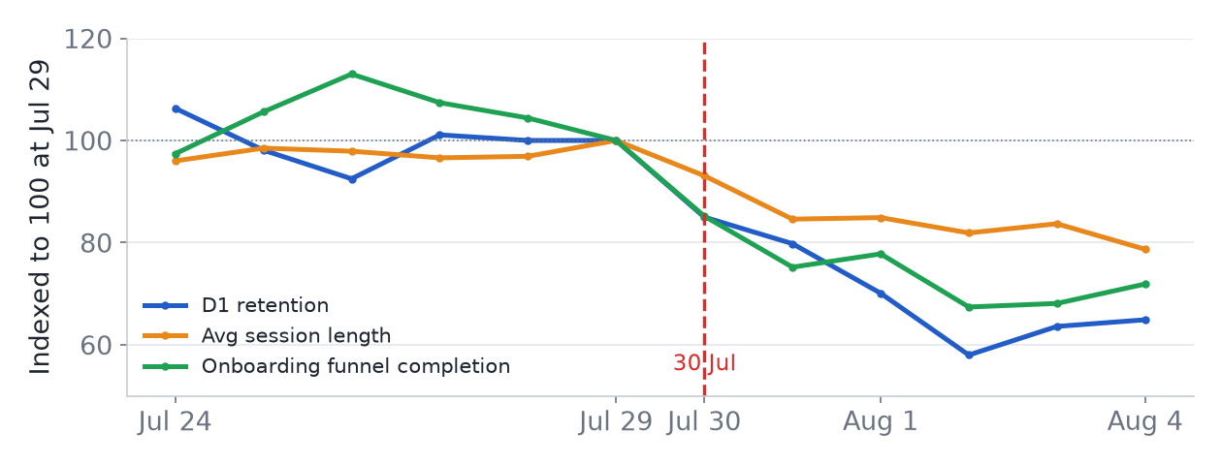
Three rate metrics indexed to 100 at Jul 29 — all flat, then all break together on 30 Jul. Event-only activity stayed flat, so the game still draws a crowd; it's the retained base that collapsed.

Part 1 — For Nina (Producer)
What's happening
Metric (Jul 29 → Aug 5) | Before | After | Change
Daily Active Users | 651K | 277K | −57%
Daily revenue | R$240K | R$101K | −58%
Paying users | 3,809 | 1,186 | −69%
Day-1 retention | 16.8% | ~10% | −35%
Avg session | 12.5 min | 9.9 min | −21%
Onboarding funnel | ~28% | ~18% | −35%

Why — the trap for new players
The 30 July update swapped the brainrot models — and some shipped with collision turned ON. For a new player two things hit at once:
- They get physically stuck and slowed by brainrots during runs (collision).
- So they can't build speed — and Rebirth 1 now needs 5,000 speed while early brainrots pay only ~$12/s. They're stuck in the first zone, never reach their first rebirth, and leave.
- Separately, some players lose their whole inventory on a bad data load and quit for good.
Good news: the collision and rebirth fixes are already in dev — they just need publishing to main. Only the data-loss fix still has to be written.
This matches exactly what players write in the downvotes:
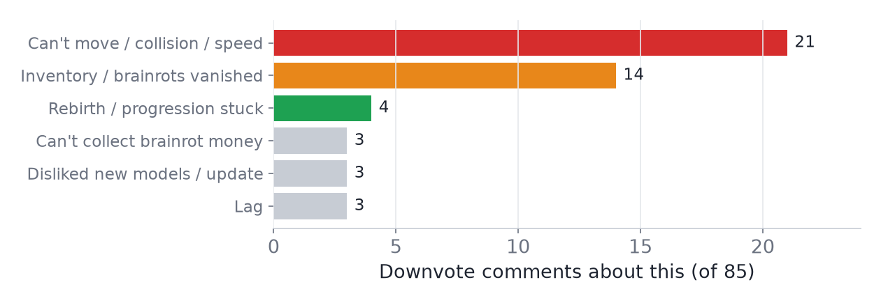
Downvote comments by theme (85). Red/orange = the confirmed causes.
What to publish
Collision + rebirth are fixed in dev → publish. But add the data-loss fix in the SAME build — it is NOT fixed in dev, so the publish alone won't stop accounts being wiped.

The one thing we need from you: confirm when the new-speed experiment (new_speed_mechanic) was widened. If it was ~30 Jul, it confirms the rebirth trap.

Part 2 — For the Dev Team
Locations + suggested fixes. We are not pushing changes — review and apply as you see fit.
1 — Brainrot collision (CONFIRMED · fixed in dev · LIVE in main)
- The swapped models shipped with collision on: high displayed speed but ~10 real speed during runs; players stuck in zone 1. #1 downvote theme (21/85).
- Verified in dev: all 129 Animals / 1,615 parts are CanCollide=false.
- But fragile — harden it: the Brainrots collision group still collides with Player, 888 parts are on Default, and no code sets the matrix (only MorphModule assigns the group). Set Brainrots↔Player non-collidable via PhysicsService so it can't regress.
2 — Rebirth 1 unreachable early (fixed in dev per team — confirm)
- The funnel breaks exactly at step 3→4 (Rebirth 1) on 30 Jul. New-speed path requires TrainedSpeed ≥ 5,000 (PlotModule.NewRebirths[1]) vs old 50. With collision slowing runs and ~$12/s early income, players stall before their first rebirth.
- Confirm the new_speed_mechanic rollout and that 5,000 is reachable early — then publish.
- Note: the Skip Rebirth product works as intended (keeps progress, grants the bonus) — not a bug.
3 — Inventory wiped on failed data load (CONFIRMED · P0 · not fixed anywhere)
- Players log in and their brainrots/cash/progress are gone. #2 downvote theme (14/85).
- ServerScriptService.OnPlayerAdded, load at ~2958:
local success, error = pcall(function()
data = playerDataStore:GetAsync(player.UserId)
end)
-- 'success' is NEVER checked. A failed load -> data == nil,
-- treated like a NEW player (defaults). Only save guard is
-- DontSave (line 443), never set on load failure -> on leave
-- defaults are written OVER the real save -> permanent loss.

- The tell: corrupt/cheat data IS guarded (DontSave + Kick, lines 3023/3081) — load-failure was just forgotten.
- Fix — guard the failed load the same way:
if not success then
player.DontSave.Value = true
player:Kick("Data failed to load - please rejoin")
return
end

- Also: retry GetAsync + session locking (neither exists). Secondary: NaN purge (line ~2986) and cash>1e60 reset (~3058) can delete legit saves if the 30 Jul math overflows — audit those.
Publish status & priority
Defect | Confidence | Fixed in dev? | Live in main? | Action
Brainrot collision | Confirmed | Yes | Yes | Publish + harden
Inventory data-loss | Confirmed | NO — dev too | Yes | Patch dev, then publish (P0)
Rebirth gate | Likely | Reported | Yes | Confirm, then publish

Before you publish — be 100% sure
1. The data-loss fix ships in the SAME build (not in dev today).
2. Collision: set Brainrots↔Player non-collidable at the group level.
3. Rebirth: confirm rollout + that 5,000 speed is reachable early.
4. Smoke-test on a copy: fresh account can rebirth; brainrots don't block movement; a forced failed load does NOT overwrite a real save.

What we ruled out
- Render/performance (Garden's ~1,781 emitters): real debt, but FPS flat, crashes improved, memory flat, and desktop sessions fell more than phone — the opposite of a render regression.
- Stolen-model swap (22 Jul): the drop started 20 Jul, before publish — exonerated.
- Admin-abuse / events: event-only metrics stayed flat while the baseline collapsed.
- "Can't collect brainrot money" (3 complaints): all 439 brainrot templates have valid income; only Lucky Blocks are 0, by design. No bug — likely a runtime edge case.
Method
Metrics come from the game's own Creator Dashboard analytics (own game, authorized data), captured with our tool. Feedback is the downvote export (85 comments) plus the reviews API (each review carries the place version it came from). Root-cause code was read directly in Studio, read-only — no game code was changed. Items marked "likely/confirm" are not fully proven.

Addendum — verification and corrections (2026-08-08)
This report was written on 2026-08-07 against analytics later found to contain defects — in particular, server-crash data was missing entirely from the tool. The game has since been re-grabbed with a corrected pipeline and every figure re-checked against Roblox's own CSV exports. One statement in the report is factually wrong. The diagnosis and the recommendations are unchanged, and the new data strengthens rather than weakens them.

Every headline number verifies
Jul 29 to Aug 5, against corrected data:
• Daily Active Users 651,235 to 276,524 (-58%).
• Daily revenue R$239,898 to R$101,072 (-58%).
• Paying users 3,809 to 1,186 (-69%).
• Day-1 retention 16.8% to 11.8%.
• Average session 13.0 to 10.0 minutes.

Correction — "crashes improved" is wrong
Under "What we ruled out", the report dismisses performance partly on the grounds that crashes improved. They did not. This game recorded 670,907 server crashes on 31 July and 1,060,617 on 1 August — inside the comparison window.
The tool held no server-crash data at the time. A query defect meant the metric was never successfully retrieved, so "crashes improved" was read from a series that was not there. That statement should be struck.

The conclusion is unchanged — and the new data supports it
The obvious worry is that a million-crash event, not the 30 July deploy, drove the decline. The corrected data rules that out on two independent grounds.
• Retention broke before the crashes peaked. Day-1 retention fell 16.8% (29 Jul) to 14.3% (30 Jul) to 13.4% (31 Jul) — already breaking on deploy day, before the 1 August crash peak.
• The decline continued after the crashes ended. Crashes returned to zero on 2-3 August, yet DAU kept falling: 492,074 (2 Aug), 413,938, 323,966, 276,524 (5 Aug). Retention stayed in the 10-12% band throughout the crash-free days.
A cause that stops while the effect continues is not the cause. The crash event overlapped the decline; it did not drive it. The 30 July deploy remains the explanation, and the code-level evidence for it — collision confirmed in Studio, the unchecked pcall on data load, the funnel breaking precisely at step 3 to 4 — is independent of any of this and unaffected.
For context, the same crash pattern hit Knife Farm, an unrelated game, on the same days, following Roblox server-engine (RCC) release 732 on 27-28 July. Knife Farm recovered fully within days of the crashes stopping. This game did not, which is the difference that matters.

What changes in practice
• Strike "crashes improved" from the ruled-out list. The rest of that section stands: FPS flat, memory flat, and desktop sessions falling more than phone still argue against a render regression.
• Priorities are unchanged. The inventory data-loss bug remains P0 and remains unfixed in dev; it is real regardless of anything above.
• When measuring recovery after the fix ships, exclude 31 July to 2 August as contaminated by the platform crash event, or the improvement will look larger than it is.

